Press release
Melle, September 2024

A fully fledged living space extension
New thermally insulated facade module with high degree of pre-fabrication for efficient facade renovation
Contact for the
editorial department:
Barbara Mäurle
Münsterweg 12
59269 Beckum
T +49 2521 82994-12
Barbara.maeurle@holtgreife.com
Contact:
Solarlux GmbH
Industriepark 1
49324 Melle
T +49 5422 92710
info@solarlux.com
www.solarlux.com
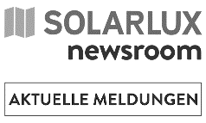
Solarlux has expanded its product range and extended its many years of expertise in moving elements made of glass to renovation projects. With the thermally insulated Ecoline M facade modules, balconies and loggias can be enclosed more quickly and efficiently than with classic mullion-transom structures, without losing their much-loved balcony-like character.

Outdoor areas in the form of balconies and loggias have become more desirable, not least since the pandemic, and offer valuable individual space, especially in multistorey apartment buildings. Here, bi-folding doors offer the best of both worlds: when closed, they create fully fledged living spaces without thermal bridges, and when open, they create a seamless transition between the indoors and outdoors to preserve the much-loved character of the balcony.

To quickly renovate the facades of outdated existing buildings with a high degree of pre-fabrication, window and facade specialist Solarlux has developed the Ecoline M module system. It combines a parapet element with an Ecoline bi-folding door to create a fixed unit with an all-round profile frame. Despite the size of the modules, the profile views and the static crossbar are narrow and create a filigree facade appearance. Furthermore, the system is characterised by concealed mounting and drainage planes. The precise dimensions and number of folding elements are individually configured during the planning phase. The modules are delivered to the construction site as prefabricated elements, and the balustrade glass and folding elements are installed on site. This modular construction significantly reduces installation times and causes minimal disruption to occupants.
For the structural connection, there are two variants available to choose from: the modules can either be mounted directly on the existing floor slab with consoles, or placed in front of it to avoid reducing the area of the balcony. A convenient cleaning pin allows the glass to be safely and easily cleaned from the inside.

The triple glazing ensures optimal Uw values of 1.1 W/(m²K) for buildings with increased requirements for an energy-efficient shell. For lower heat insulation requirements, the system is also available with non-insulated slide-and-turn elements in an SL Modular variant from Solarlux. Further product expansions, e.g. with photovoltaics in the balustrade, will also be available soon.
www.solarlux.com
Solarlux GmbH, September 2024 – Reprinting permitted – 2,424 characters (incl. spaces)
Please send a copy to our Press Office in Beckum.

Images: Solarlux GmbH

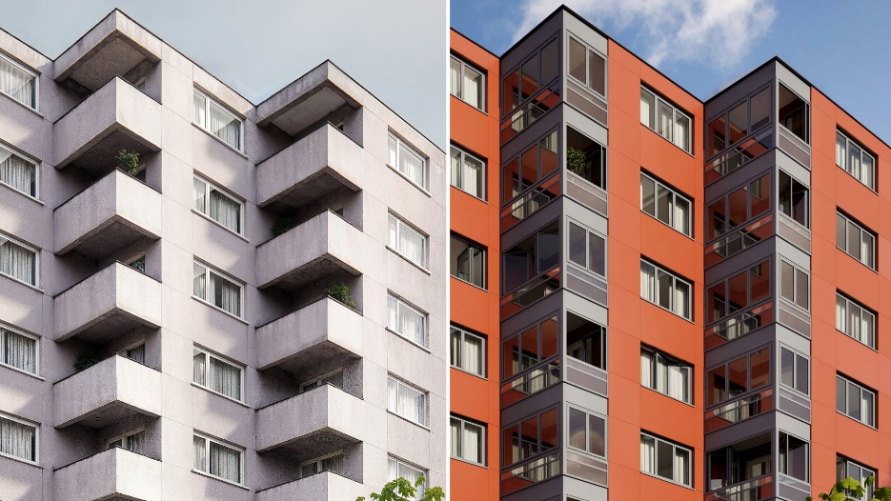
Solarlux_Fassadenmodul_warm_vorher_nachher_04: Before and after effect: In the course of a facade renovation, the Ecoline M transforms formerly exposed balconies into fully fledged expansions of the living space, while retaining their balcony-like character with bi-folding doors.

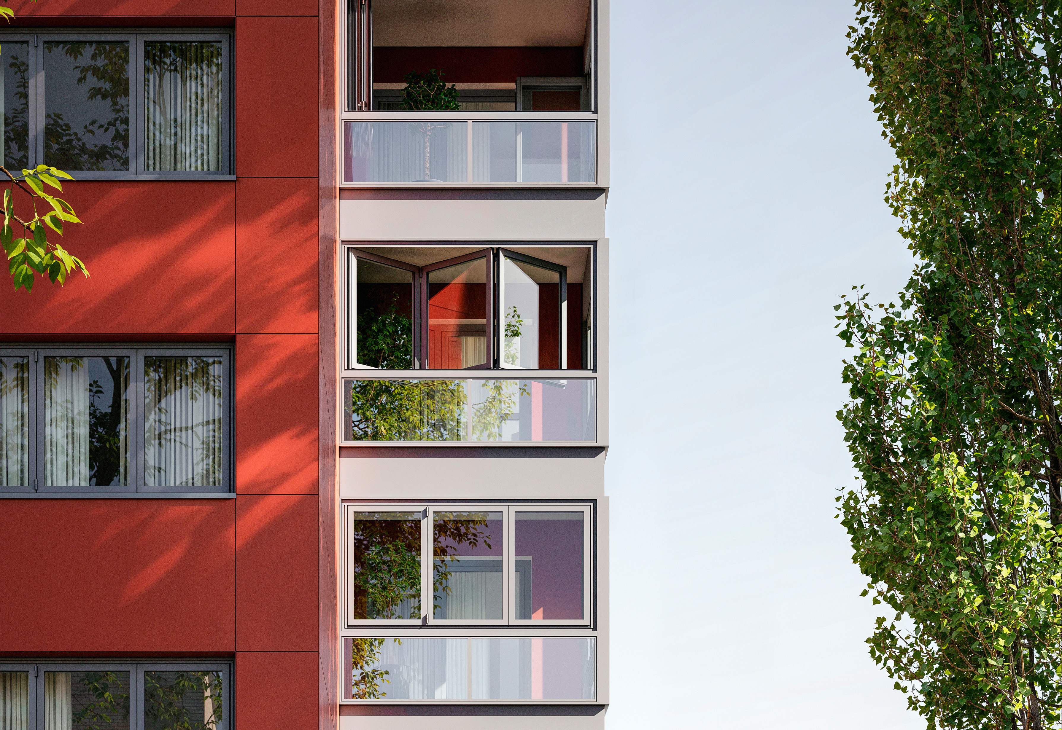
Solarlux_Fassadenmodul_Fassade_Ausschnitt.jpg: The Ecoline M facade module enables the full expansion of the living space, without losing the character of the balcony.
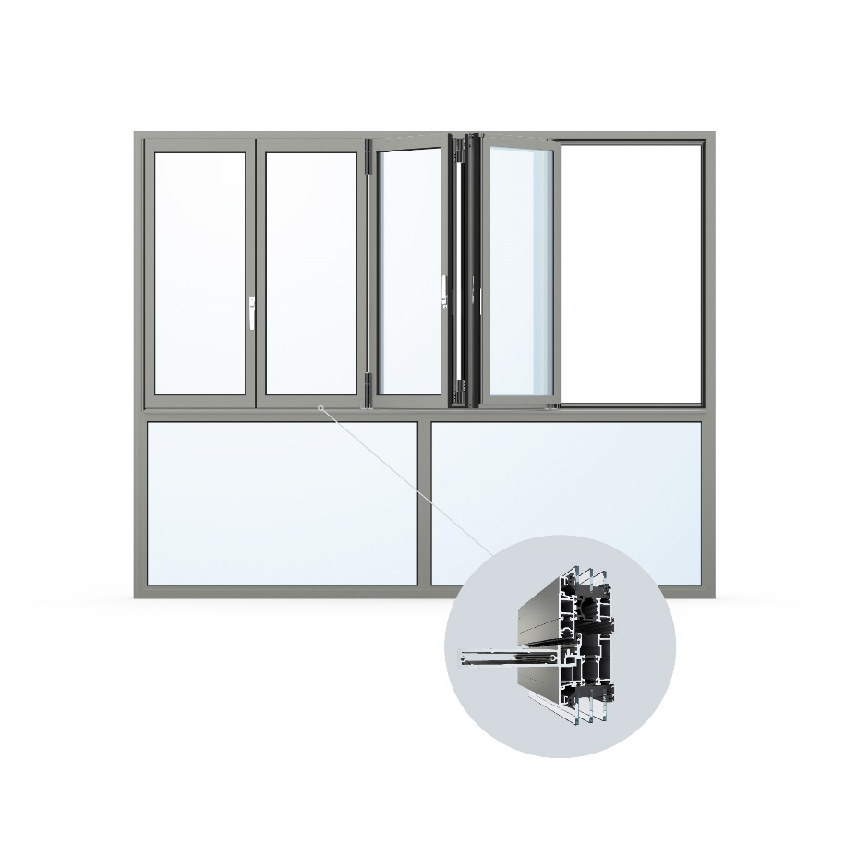
Solarlux_Fassadenmodul_warm_Zeichnung.jpg: The thermally insulated Ecoline M facade module combines a parapet element with an Ecoline bi-folding door to create a fixed unit with an all-round profile frame.

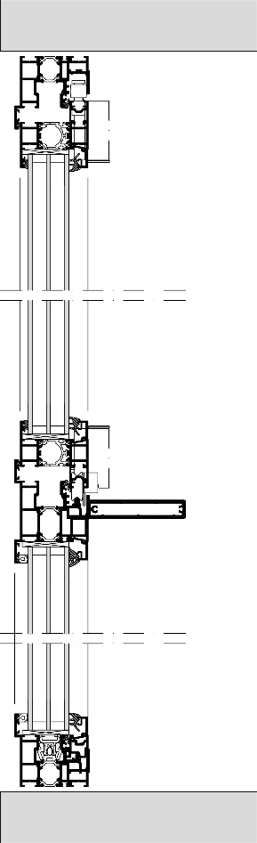
Schnitt Ecoline Modul 3_fach Verglasung.jpg: Longitudinal section of the Ecoline M facade module. The lower parapet element is only coupled to the upper bi-folding doors with a narrow static crossbar.

Images: Solarlux GmbH
Copyright: The following rights of use apply:
- Use is only permitted when clearly intended to present or promote the services, products or projects of Solarlux GmbH. Publication for any other purpose is prohibited without written approval from Solarlux.
- The publication of the images is only permitted in print, web and social media environments.
- For any other type of publication, the copyright notice included in the image’s metadata must be published together with the image (e.g. “Photo: Solarlux GmbH” or “*Photographer’s name* for Solarlux GmbH” or “Photographer’s name”).
- It is not permitted to pass the images on to third parties.
- Editing of the images is only permitted insofar as this does not alter the core message of the image.
- Use is not subject to any limitations in terms of time or geographical location.

Social media
Hashtags: #Solarlux #Facade #BalconyGlazing

Solarlux on LinkedIn:
https://www.linkedin.com/company/solarluxgmbh/
Solarlux on Instagram:
https://www.instagram.com/solarlux/
Solarlux on Facebook:
https://www.facebook.com/solarlux/

About Solarlux GmbH
Solarlux has been a specialist in flexible window and facade solutions from a single source for more than 40 years. All its products – from bi-folding glass doors, sliding windows and glazed extensions to balcony glazing and curtain walls – are developed in-house, produced to order and built to “made in Germany” quality standards. The German, family-owned company specialises in providing comprehensive support to architects, building owners and craftsmen as a partner in the planning and implementation of building projects. Solarlux skilfully combines attention to detail and innovation – with the aim of developing the optimal solution for the complex needs of every project. Founded by Herbert Holtgreife and based in the town of Melle, north-west Germany, the company is now in its second generation, managed by Holtgreife’s son, Stefan. Around 1000 employees work at the company headquarters, the Solarlux Campus, and across 45 sales locations worldwide.

Solarlux has won awards from the German Design Council several years running for its outstanding and exemplary product design in a range of produce groups, including German Design Award, the Iconic
Awards: Innovative Architecture and the iF Design Award.

