Contact person
in the editorial department

Barbara Mäurle
holtgreife | Büro für Markenkommunikation
Münsterweg 12, 59269 Beckum, Germany
T +49 2521 829940
Barbara.maeurle@holtgreife.com

Contact us
Solarlux GmbH
Industriepark 1, 49324 Melle, Germany
T +49 5422 92710
info@solarlux.com
solarlux.com



Press release
Melle, November 2025

Transforming space into art
Raphaels Refugium in Graz

An up-and-coming art dealer has achieved their dream of open-plan living in the heart of Graz's old town. You won't find any conventional partition walls in Raphaels Refugium. Boasting impressive views over the rooftops of the UNESCO World Heritage Site, the unparalleled loft seemingly extends in every direction – from left to right, up and down, even inside to out. All made possible by Graz-based architectural firm LOVE architecture and a client who wasn't afraid to open up spaces and employ some creative freedom.
Spread across 224 sqm, the loft is on the top floor of an extended old building in Graz city centre. A rooftop extension was added to the historic building back in 2018. LOVE architecture worked with the layout of the existing building to create an open-plan, one-room loft concept. They concluded that any partition walls added would detract from the desired loft character.

When the space was repurposed from a former office to an apartment, structural interventions were kept to a minimum: "We have not added any fixed structural elements. Everything was designed with an open plan in mind", explains Mark Jenewein, Partner at LOVE architecture. "The space is divided by free-standing design pieces, creating different sections."

Seamless transition between inside and out

In order to stay true to the loft's open-plan layout in the outdoor area, the pre-existing mullion-transom facade was renovated with consideration given to the building's structural properties and two bi-folding doors from Solarlux were installed. "Our aim was to make the loft as limitless and open as possible", adds Jenewein. "On hot summer days, indoors and outdoors merge to create one continuous space, whereas in the winter, the glass provides optimal vistas." Bi-folding doors proved to be the ideal solution. Compared to conventional sliding doors, the elements in bi-folding doors can be fully folded to the side in slim glass bundles.
The individual glass elements in the bi-folding doors needed to be a maximum of 1.3 metres wide while seamlessly blending into the loft's design. In order to satisfy this requirement, the Megaline system from Solarlux was chosen. The Megaline system permits an element height of up to 4.5 metres and widths of up to 1.5 metres without any compromise on free movement and convenience. Despite these dimensions, the sight line in the panel amounts to just 132.5 mm.
www.solarlux.com

Solarlux, November 2025 – Reprinting permitted – 2,332 characters (including spaces)
Please send a copy to Agentur holtgreife in Beckum.

Image credits: Stefan Leitner

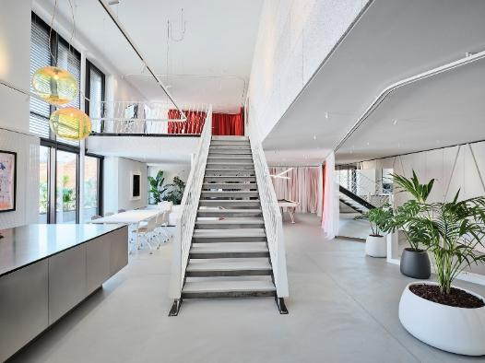
solarlux-glas-faltwand-megaline-ref02094-114.jpg: LOVE architecture transformed the former office into an open-plan living concept that preserves the original loft character.
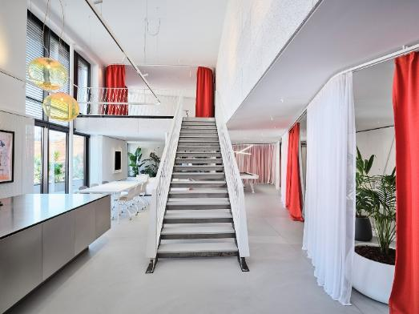
solarlux-glas-faltwand-megaline-ref02094-115.jpg: A floor-to-ceiling curtain provides privacy when required while also positively contributing to the loft's acoustics.
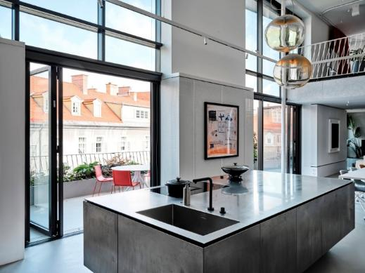
solarlux-glas-faltwand-megaline-ref02094-015.jpg: The seamless room concept continues outside, with the pre-existing facade being opened up with two bi-folding doors from Solarlux.

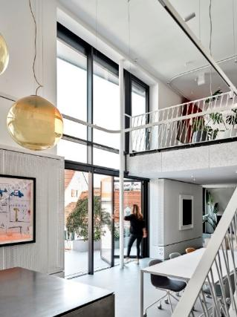
solarlux-glas-faltwand-megaline-ref02094-010.jpg: Compared to conventional sliding doors, bi-folding doors can be fully folded to the side.

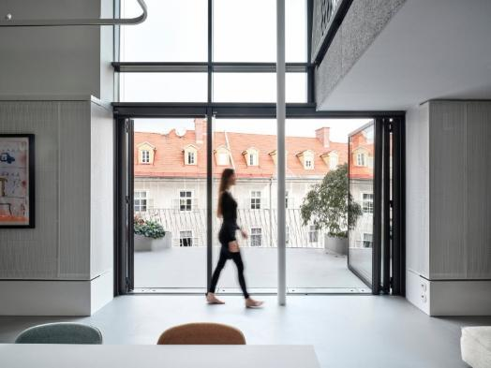
solarlux-glas-faltwand-megaline-ref02094-004-01.jpg: The Megaline bi-folding door system facilitates exceptionally wide or tall wing elements for large-scale openings.

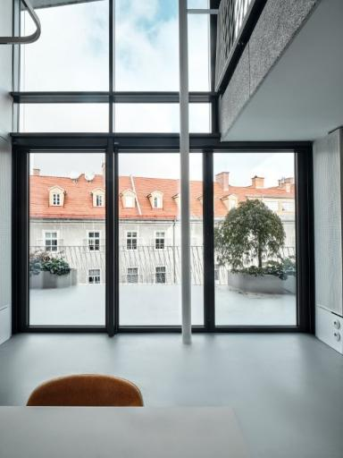
solarlux-glas-faltwand-megaline-ref02094-007.jpg: The slim profile and three, roughly 1.3-metre wide glass elements ensure a close connection to outside, even when the bi-folding doors are closed.

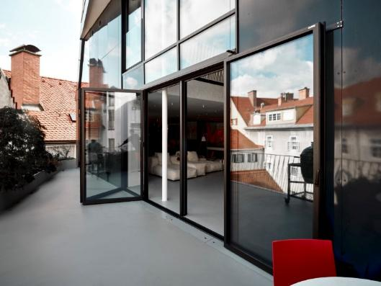
solarlux-glas-faltwand-megaline-ref02094-029.jpg: When opened, the bi-folding doors and continuous flooring connect inside and out to form one seamless space.

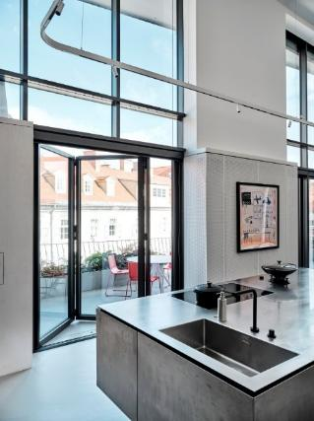
solarlux-glas-faltwand-megaline-ref02094-012.jpg: Accessible floor tracks with just 14 mm rebate for seamless transitions.

Copyright: Stefan Leitner
The following usage rights apply
- This content can only be used to present or promote the services, products or projects of Solarlux GmbH. Any further publication requires written permission from Solarlux.
- The images may be published in print, online and on social media.
- Each time an image is published, the image's meta data must be published containing the copyright notice (e.g. "Image: Solarlux GmbH" or "[name of photographer] on behalf of Solarlux GmbH" or "[name of photographer]".)
- Images may not be passed on to third parties.
- Images may only be edited if the main message conveyed by the image is not obstructed.
- The granted usage rights are unlimited in terms of territory and time.

About Solarlux GmbH
Solarlux has been a specialist in moveable window and facade solutions from a single source for more than 40 years. All Solarlux products – ranging from bi-folding doors, sliding doors and glazer extensions to balcony glazing and curtain walls – are developed in-house, produced to order and built with passion and precision to “made in Germany” quality standards. The German company specialises in providing comprehensive support to architects, craftsmen and building owners as a partner in the planning and implementation of building projects. This involves skillfully combining diligence and inventiveness with the overarching goal of producing the optimal solution for even the most demanding of projects. Founded by Herbert Holtgreife and based in the town of Melle, Lower Saxony, the company is now in its second generation and managed by Holtgreife’s son, Stefan Holtgreife. Around 1000 employees work at the company headquarters in the Solarlux campus and at 45 sales locations worldwide.



